BAXTER HEALTHCARE
Process in the Holonic Semantic Architecture
How Process Is Designed, Realized, Governed, and Executed Across the Layers

Solution Design Document
The Value Enablement Group, LLC · Jeffrey Wallk · May 2026
CONFIDENTIAL

Reading guide: Key insights appear in bold yellow highlight. Architectural principles appear in bold green highlight. Technical terms appear in monospace.

1. The Core Problem — Why Process Replication Fails

Every conventional enterprise architecture replicates process. A pharmaceutical compounding procedure exists in a paper SOP, then in the MES batch record template, then in the ERP production order structure, then in the LIMS method definition, then in the QMS deviation classification schema, then in a BPM workflow tool trying to orchestrate across all of them. Each copy diverges. Process becomes the source of the very inconsistencies the architecture was supposed to prevent.

The holonic architecture solves this not by finding a better single repository for process, but by recognizing that process is not a document or a workflow definition — it is a governed relationship between state transitions. What you store is the governance contract for those transitions. The process itself executes in the physical world; only its rules, its history, and its current state exist in the digital layer — at three different holonic levels that are never collapsed into a single representation.

The traditional approach and its failure modes:
- Replication drift: SOP, MES batch record, ERP order, LIMS method, and BPM workflow each hold a copy of process logic. Changes propagate incompletely. After two years, no two copies agree.
- Validation re-work: Every copy in a GxP context requires independent validation. Process improvements must be implemented and validated in N systems rather than one.
- Invisible emergence: When a technician discovers a better technique, it stays in their head or in a lab notebook. The system has no governed mechanism to absorb improvement without replication creating another divergence point.
- Audit fragility: An FDA inspector asking 'which process was in effect for this batch?' must be answered by cross-referencing multiple system copies, hoping they agree. They frequently do not.

The holonic answer: Process is represented once at each holonic level — not as a copy of the same document, but as a complementary aspect. The governance layer holds the rules. The knowledge graph holds the history. The digital twin holds the current state. The physical layer holds the execution. These four aspects are orthogonal, not redundant.

2. The Five-Level Process Architecture

A process in the holonic architecture exists simultaneously at five levels, each holding a different aspect — not a copy, but a complementary perspective. Each level holds the kind of authority that naturally belongs to it and has no business replicating what belongs to another level.

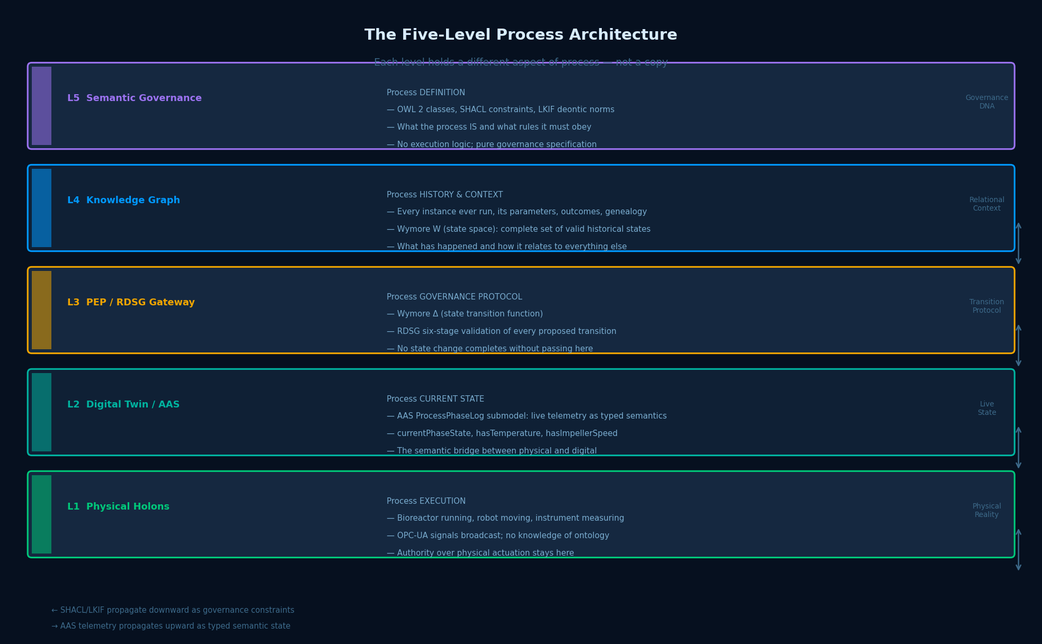

Figure 1: The Five-Level Process Architecture — Five complementary aspects, no replication

Layer 5 — Semantic Governance: Process DEFINITION

Layer 5 holds the definition of what the process IS and what rules govern it. This is expressed in three formal languages that work together: OWL 2 class definitions (the ontological identity of the process concept), SHACL constraint shapes (the formal specification of what valid process instances look like), and LKIF deontic norms (the prescriptive obligations, permissions, and prohibitions that govern process behavior). The Compounding Process class in the OWL ontology defines the concept. The SHACL shape specifies that pH must remain between 6.8 and 7.2 during the mixing phase. The LKIF obligation states that every parameter change must be logged. None of this contains execution logic. It is governance specification only.

Layer 4 — Knowledge Graph: Process HISTORY & CONTEXT

Layer 4 holds every process instance ever run — its parameters, its outcomes, its genealogy connections, its deviations, and its regulatory relationships. This is Wymore's W (the state space) — the complete set of valid historical and current states available for reasoning. When a scientist asks which prior compounding batches shared a specific excipient lot with batches that failed dissolution testing, the Knowledge Graph answers this in seconds without touching any source system. The six named graphs (R&D, Clinical, Manufacturing, Supply Chain, Regulatory, Governance) provide provenance isolation — process data from one domain is queryable alongside data from other domains without those domains being merged.

Layer 3 — PEP / RDSG Gateway: Process GOVERNANCE PROTOCOL

Layer 3 is the most architecturally consequential layer. It holds Wymore's Δ — the state transition function. Every proposed change to process state — whether from a human, an AI agent, an automated service, a robotic system, or a sensor event — must pass through the six-stage RDSG traversal before the transition completes. The RDSG does not know what the process does physically. It knows what rules the process must satisfy. This is the formal definition of structural governance: it is not possible to bypass the governance layer because the governance layer is the transition mechanism.

Layer 2 — Digital Twin / AAS: Process CURRENT STATE

Layer 2 holds the live semantic state of process execution through the Asset Administration Shell. The AAS ProcessPhaseLog submodel carries real-time telemetry — currentPhaseState : PhaseState_Mixing, hasTemperature : 37.2 [°C], hasImpellerSpeed : 250 [RPM] — generated from the OPC-UA signal stream via Siemens IOX and converted to typed RDF triples. The AAS is the semantic bridge between physical execution and digital governance. It does not replicate the MES batch record. It provides a typed, ontology-conformant representation of current physical state that the Knowledge Graph and RDSG can reason over.

Layer 1 — Physical Holons: Process EXECUTION

Layer 1 is the physical reality — bioreactors running, robots moving, instruments measuring, environmental systems monitoring. The physical layer does not know about OWL ontologies or SHACL constraints. It publishes OPC-UA signals and receives actuation commands. Authority over physical execution stays here and was already validated through equipment qualification. Nothing in the holonic architecture modifies how the physical layer operates internally. This is why no GxP equipment qualification is invalidated by FABRIC integration.

3. The Formal Standards Bridge — VDI/VDE 3682, ISA-88, and Wymore Model M

Three formal frameworks provide the structural vocabulary for process in the holonic architecture. Their alignment eliminates the translation overhead that conventional multi-standard approaches require — they describe the same governed process at the ontological, procedural, and formal-mathematical levels respectively.

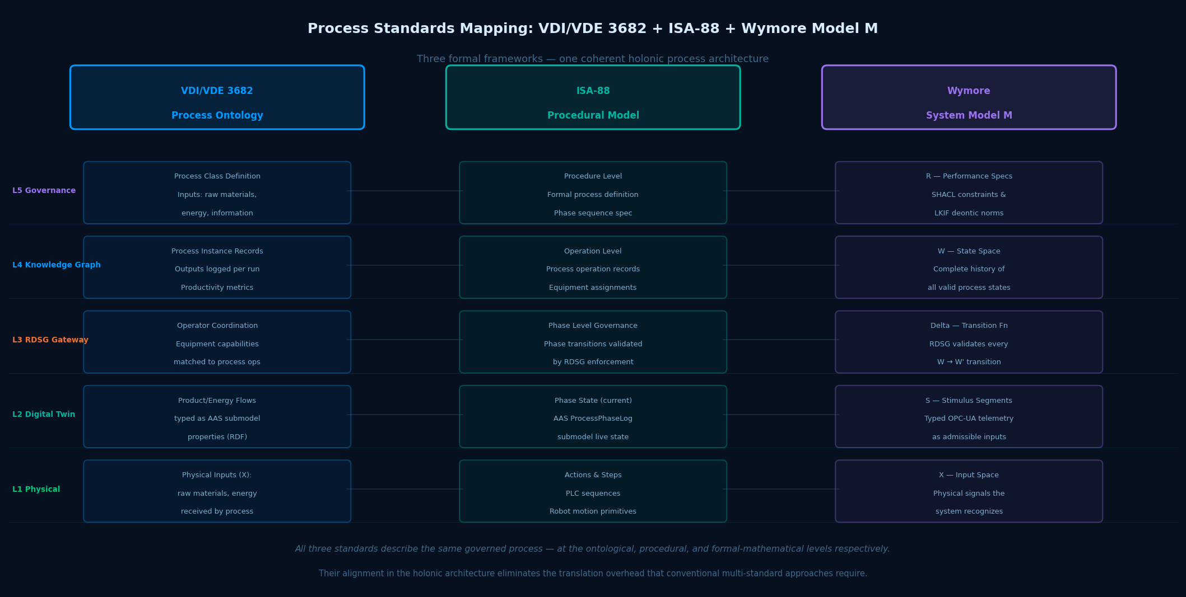

Figure 2: VDI/VDE 3682 + ISA-88 + Wymore Model M — Three frameworks, one coherent architecture

VDI/VDE 3682 — Process Ontology

VDI/VDE 3682 represents manufacturing processes as formal models with four components: inputs (raw materials, energy, information entering the process), outputs (finished products, waste, data produced), operators (equipment, humans, agents), and the process itself as the transformative relationship. In the holonic architecture, this maps onto the OWL 2 process class hierarchy: every process has typed input slots, typed output slots, designated equipment operators linked to AAS shells, and a formal state machine governing its phases.

The Compounding Process OWL class carries hasInput → RawMaterial (API, excipient, solvent), hasOutput → IntermediateProduct, operatedBy → BioreactorEquipmentClass, and hasPhaseSequence → [Charging, Mixing, Sampling, Transfer]. These are not attributes on a database record. They are formal ontological relationships that every process instance inherits and that the SHACL engine validates every instance against.

ISA-88 — Procedural Hierarchy

ISA-88 provides the procedural hierarchy that maps to holonic levels with precision:
- Procedures (L4/L5 — Knowledge Graph + Semantic Governance): The top-level process definition — phase sequence specification and inter-phase dependencies. Stored once in the ontology. Every batch run is an instance of the Procedure class.
- Operations (L3 — RDSG Gateway): The governed sequences within which phase transitions are validated. The RDSG enforces ISA-88 operation-level logic as SHACL constraints on the transition sequence.
- Phases (L2 — AAS Digital Twin): The current state of execution. The AAS ProcessPhaseLog submodel holds the live phase state, updated in real time from OPC-UA telemetry.
- Actions and Steps (L1 — Physical): PLC sequences, robotic motion primitives, instrument commands. Stays in the control system. Not modified by FABRIC.

Wymore Model M — Formal Mathematical Specification

Wymore's system model (M = (X, Y, W, S, Δ, Λ, R)) provides the formal mathematical guarantee that process behavior is well-defined at every holonic level:

X — Input Space | All typed inputs the process can legally receive: OPC-UA telemetry streams, human commands via Mendix HITL, AI agent proposals via RDSG RCB. Anything not typed and admitted by Layer 2 does not enter the architecture.
Y — Output Space | All typed outputs the process produces: validated batch records, RDF triples to the Knowledge Graph, KGCL change records, actuation commands to physical systems, regulatory evidence packages.
W — State Space | The complete set of valid process states across all instances and all time. Implemented in the Knowledge Graph (L4). Every valid process configuration and historical outcome.
S — Stimulus Segments | Admissible input sequences — the specific patterns of telemetry and commands that the process governance architecture recognizes and accepts. Defined by SHACL input constraints.
Δ — Transition Function | The RDSG six-stage traversal. Every state change from W to W′ is governed here. Non-compliant transitions are blocked. This is structural governance — Δ is the governance, not a filter on top of it.
Λ — Output Function | The semantic transformation from current state to governed outputs: AAS RDF triples, Knowledge Graph updates, HITL alerts, compiled AI directives, physical actuation commands.
R — Performance Specs | The SHACL constraint library + LKIF deontic norm library. The complete formal specification of what must be true of every state transition. Authored at L5, enforced at L3.

4. RDSG Insertion Points — Where Automation Enters and Exits

The six stages of the RDSG are the natural, formal insertion points for every category of automation — services, UX components, AI agents, robotics, and ML systems. They are not arbitrary — they correspond to the six distinct governance boundaries that any automated system must cross when proposing or executing a process intervention. Nothing enters or exits the holarchy except through these six stages. This is what makes governance structural rather than procedural.

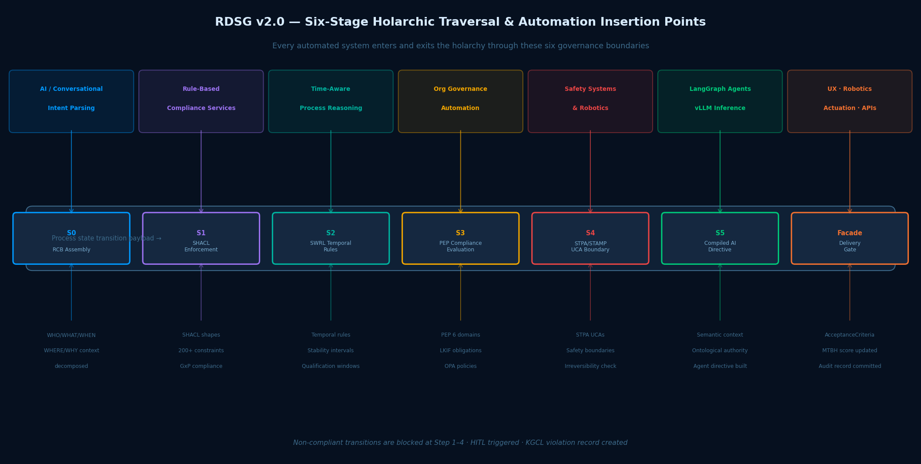

Figure 3: RDSG v2.0 Six-Stage Traversal — The formal insertion points for all automation categories

Stage 0 — RCB Assembly: AI and Conversational Intent

Stage 0 is the insertion point for AI agents that interpret human intent and decompose it into governed process context. The LangGraph formulation synthesis agent, a voice-activated lab assistant, a scientist's natural language query — all of these enter the holarchy at Stage 0. The incoming request is decomposed into its five relevancy dimensions (WHO, WHAT, WHEN, WHERE, WHY) and translated into a Requirement Context Bundle that activates the appropriate domain process holons. The scientist does not navigate the ontology manually. The RCB Assembly translates intent into structured governance context.

Step 1 — SHACL Enforcement: Rule-Based Compliance Services

Step 1 is the insertion point for any service that proposes a process state change — a formulation optimization service, a scheduling system, a LIMS interface proposing to advance a sample, a UX component offering a confirmation button. All proposed state transitions are automatically evaluated against the 200+ SHACL shapes in the constraint library. This check is structural — it cannot be bypassed because the SHACL enforcement engine is the path through which state change proposals travel. The service does not implement compliance logic. It submits a proposal and receives a governance decision.

Step 2 — SWRL Temporal Rules: Time-Aware Process Reasoning

Step 2 is the insertion point for time-sensitive process automation — scheduling systems, stability monitoring, equipment qualification management. SWRL temporal rules evaluate whether the proposed state transition is valid at the current point in time: Is the stability interval still within specification? Has the supplier qualification window expired? Is the current batch phase the correct one for the proposed action? A robotic liquid handler proposing to transfer a sample triggers SWRL temporal rule evaluation automatically. The robot does not know the stability protocol intervals. The holarchy applies them.

Step 3 — PEP Compliance Evaluation: Organizational Governance Automation

Step 3 is the insertion point for the six Policy Enforcement Point domains: Compliance (GxP, 21 CFR Part 11), Risk (FMEA/STPA), Legal (IP, contracts), Security (OPA/RBAC), Data Governance (DQS), and AI Governance (MTBH). Each domain evaluates the proposed process action against its LKIF deontic norm set. A UX component presenting a process action to a scientist cannot render the authorization button until Step 3 returns a governance clearance across all six domains. The UX does not implement compliance logic — it renders the governance decision.

Step 4 — STPA/STAMP UCA Boundary: Safety Systems and Robotics

Step 4 is the insertion point for robotic systems, automated lab equipment, and any actuation that could affect physical safety or process integrity. Every proposed process action is checked against the Unsafe Control Action specification derived from Systems Theoretic Process Analysis. The STPA specification is not embedded in the robot's control logic — where re-qualification would be required every time the safety boundary is updated. It is evaluated by the RDSG at the governance boundary. The robot receives only authorized action directives. Safety governance updates are instantaneous across all connected robots without equipment re-qualification.

Step 5 — Compiled AI Directive: LangGraph Agents and LLM Inference

Step 5 is the insertion point for AI agents that execute — generating recommendations, drafting regulatory text, synthesizing formulation knowledge, performing root cause analysis. The agent receives not the user's raw request but a Compiled AI Directive — a governance package carrying the semantic authority of every domain holon touched in Steps 1–4, the ontological context of the current process instance, and the constraints within which the agent is permitted to reason. The agent operates within the holarchy, not on top of it. Hallucination is structurally constrained because the agent can only propose outputs consistent with the governed context it received.

Service Facade — Delivery Gate: Outputs to Physical and Digital Consumers

The Service Facade is the exit point — where governed outputs reach their consumers. Robot actuation commands, UX state updates, API responses to downstream systems, Mendix workflow triggers, Teamcenter BOP pushes, SAP BOM updates — all exit through the Service Facade after AcceptanceCriteria validation, MTBH score update, and KGCL audit record commitment. A robotic arm receives an actuation command only after all six governance stages have been traversed. A Mendix dashboard reflects a process state change only after that change has been committed to the Knowledge Graph with full provenance.

5. The Process Holon Pattern — Whole and Part Simultaneously

A process in the holonic architecture is a holon — simultaneously a self-governing whole, bounded by its own SHACL invariants and LKIF obligations, and a composable part of a larger process holarchy. This dual nature is not a design choice — it is the formal property that makes process scalable without replication.

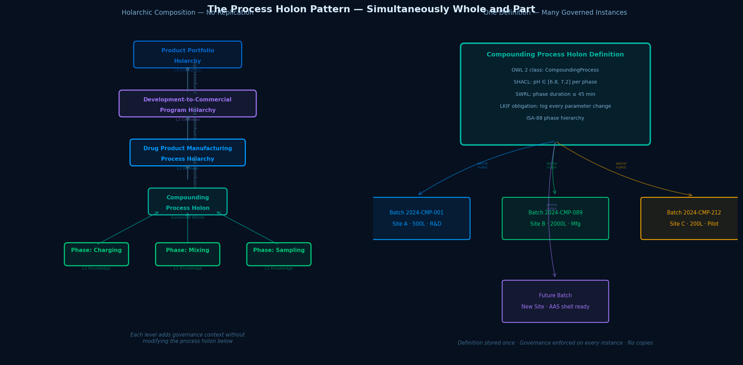

Figure 4: The Process Holon Pattern — One definition governs all instances; holarchic composition without replication

The Compounding Process as a Self-Governing Whole

The Compounding Process holon has its own OWL 2 class definition, its own SHACL shape specifying valid parameter envelopes, its own SWRL temporal rules governing phase durations, and its own LKIF obligations about what must be logged and approved. It is self-governing in Koestler's sense — it can operate correctly (produce valid instances, enforce its constraints, generate its outputs) without reference to any other process. A compounding batch at a new site that has never run this process before is immediately governed correctly, because the process holon definition travels with the AAS shell that identifies it.

The Compounding Process as a Composable Part

The Compounding Process holon is also one operation within the Drug Product Manufacturing Process holarchy, which is itself one phase of the Development-to-Commercial Program holarchy, which is part of the Product Portfolio holarchy. Each level adds governance context without modifying the process holon below it:
- Drug Product Manufacturing Process holarchy defines how compounding relates to filling and lyophilization — the cross-process sequencing constraints and material handoff specifications.
- Development-to-Commercial Program holarchy defines how the manufacturing process relates to the clinical trial that validated the formulation — the lineage that an FDA inspector needs to trace.
- Product Portfolio holarchy defines how this product's manufacturing compares to others sharing equipment or raw material suppliers — the cross-product risk context for supply chain and operations.

Adding a new manufacturing site does not require rewriting the Compounding Process definition. Adding a new formulation does not duplicate the governance framework. The process holon is defined once at the appropriate holonic level. New instances are governed by the same definition, connected to the holarchy through the AAS-to-Knowledge-Graph bridge, validated by the same SHACL constraints. The governance scales structurally — it does not add governance overhead proportional to the number of process instances.

6. Governed Emergence — How Bottom-Up Discovery Becomes Top-Down Governance

Emergence — a robot discovering a better mixing parameter, an AI agent identifying a novel stability pattern, a scientist observing an unexpected improvement — is absorbed into the holarchy through the KGCL protocol, which is the formal mechanism by which physical discovery becomes semantic governance. The holarchy does not prevent emergence. It governs when emergence becomes operational reality.

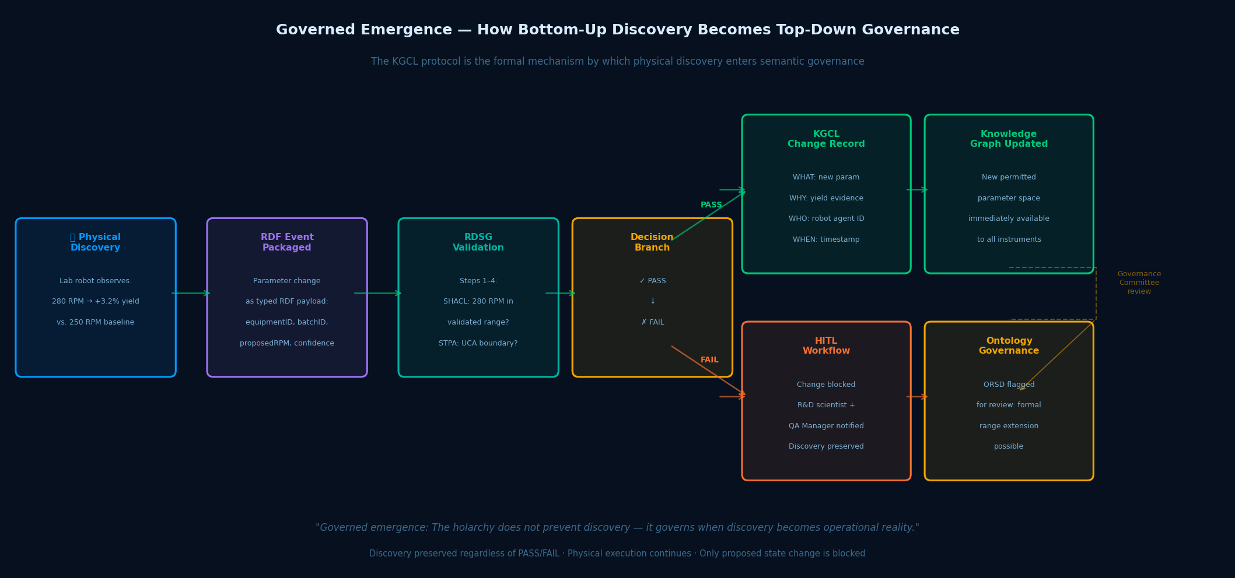

Figure 5: Governed Emergence — From physical discovery to semantic governance via the KGCL protocol

The Compounding Robot Example — Step by Step

A lab robot running a compounding protocol observes that 280 RPM impeller speed produces 3.2% higher yield than the validated 250 RPM baseline. Here is how the holonic architecture handles this:

1. Physical Discovery | Robot's embedded ML identifies the correlation. Packages the observation as an RDF event payload: equipmentID, batchID, proposedImpellerSpeed=280, confidence=0.91, yieldDelta=+3.2%.
2. RDSG Submission | RDF event submitted to the RDSG Stage 0. RCB assembled: WHO=robot agent, WHAT=ImpellerSpeed, WHEN=current batch phase, WHERE=R&D named graph, WHY=yield optimization intent.
3. SHACL Evaluation (Step 1) | SHACL checks: is 280 RPM within the validated parameter range? If the current SHACL constraint specifies maxInclusive=300 RPM, it passes. If it specifies maxInclusive=260 RPM, it fails.
4A. PASS path — KGCL record | Transition approved. KGCL change record created: WHAT (280 RPM now permitted), WHY (yield evidence, confidence score), WHO (robot agent ID), WHEN (timestamp). Knowledge Graph updated.
4B. FAIL path — HITL triggered | Transition blocked. KGCL violation record created. Mendix HITL workflow routes to R&D scientist and QA Manager. Discovery preserved as a proposed-but-unvalidated improvement artifact in the Knowledge Graph.
5. Governance review (both paths) | Ontology Governance Committee reviews the KGCL record at next bi-weekly meeting. If evidence supports formal range extension, the SHACL constraint is updated — governed, version-controlled, immediately effective everywhere.

The robot's discovery is preserved regardless of the PASS/FAIL outcome. A failed governance check does not discard the knowledge — it quarantines it as a proposed improvement pending formal authorization. The physical system continues running. Only the proposed state change to the Knowledge Graph is blocked. This is the formal definition of governed autonomy: machines can discover; only the holarchy can authorize discovery becoming operational standard.

7. Digital-Physical Process Sharing — The AAS as Semantic Bridge

The AAS (Asset Administration Shell) is the sharing mechanism — and its design elegantly prevents the divergence problem that plagues conventional digital-physical integration. The physical system and the digital governance layer interact through a semantic bridge that gives each layer the representation it needs without requiring either to adopt the other's model.

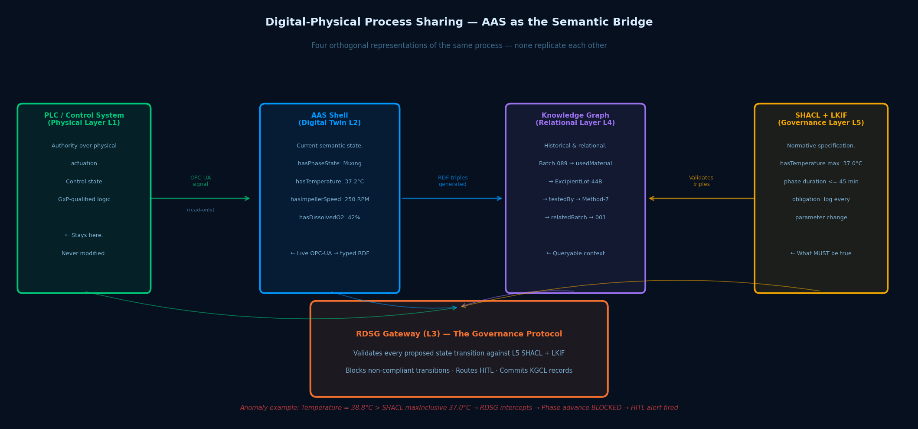

Figure 6: Digital-Physical Process Sharing — Four orthogonal representations, one governed entity

Four Orthogonal Representations — Why They Do Not Diverge

The insight that makes the AAS approach correct is that the four representations are genuinely orthogonal — they describe different things, not the same thing in different formats:
- The PLC / Control System holds the control state — the authority over physical actuation, GxP-validated logic, and the equipment qualification status. It stays here. Nothing in FABRIC modifies it.
- The AAS Shell holds the current semantic state — real-time telemetry typed against the OWL 2 ontology. Temperature is not just a number; it is hasAmbientTemperature : xsd:double [UOM: Celsius, xsd:minInclusive: 36.0, xsd:maxInclusive: 37.0]. The unit, the range, and the type travel with the value.
- The Knowledge Graph holds the relational and historical context — every batch that ran on this equipment, every material lot that entered it, every deviation that occurred, every regulatory filing that references it
- The SHACL + LKIF Governance Layer holds the normative specification — what must be true of every process instance. Not what is true now, but what must be true. The constraint hasTemperature maxInclusive 37.0 is enforced against every AAS temperature value the Knowledge Graph receives.

The Anomaly Detection Flow — Temperature Excursion Example

When the bioreactor temperature rises to 38.8°C — 1.8°C above the SHACL maximum — the holarchy responds:
Signal broadcast | Bioreactor PLC broadcasts OPC-UA signal: Temperature_Tag_07 = 38.8°C at timestamp T.
AAS mapping | Siemens IOX reads the signal. Maps to AAS ProcessPhaseLog: hasAmbientTemperature = 38.8 [°C] with timestamp T. AAS submodel updated.
RDF triple generation | AAS shell generates RDF triple: <BatchInstance-089> <hasAmbientTemperature> "38.8"^^xsd:double. Triple submitted to Knowledge Graph ingest pipeline.
SHACL evaluation | Stardog SHACL engine evaluates the triple against the CompoundingProcess shape: hasAmbientTemperature maxInclusive 37.0 — VIOLATION.
RDSG intercepts | Any subsequent API call or automated action attempting to advance BatchInstance-089 to the next process phase is intercepted by the RDSG. Phase advance blocked at SHACL Step 1.
HITL alert | Mendix workflow triggers. Process engineer receives an alert with: current temperature reading, applicable SHACL constraint, timestamp of excursion, and the HITL Intervention Pane showing proposed vs. required state.
Physical system continues | The bioreactor is not stopped. The governance layer does not control the physical execution layer. It controls what state changes are committed to the governed knowledge fabric.

Critical principle:
Digital governance acts as a semantic overlay on physical execution, not a replacement for the control system's authority. The PLC governs what the bioreactor does. The holarchy governs what knowledge is committed and what state transitions are authorized. These are separate authorities operating on separate planes — which is exactly why GxP equipment qualification is never at risk.

8. End-to-End: The Compounding Process Across All Layers

The following traces a single compounding batch from process design through physical execution, demonstrating how each holonic layer contributes its unique aspect without replicating any other layer's contribution.

Phase A — Process Design (L5 Governance + L4 Knowledge Graph)

A process engineer and ontology knowledge engineer use VocBench 3 to author the CompoundingProcess OWL class with its ISA-88 phase structure (Charging, Mixing, Sampling, Transfer), its SHACL shapes (pH 6.8–7.2, temperature 36.0–37.0°C, impeller speed 230–270 RPM, phase duration ≤ 45 minutes), its SWRL temporal rules (stability interval enforcement, retest date calculation), and its LKIF obligations (log every parameter change, require QA sign-off before phase advance). The Ontology Governance Committee reviews and approves. The definition is deployed to Stardog.

Design-time cost: one. Run-time instances: unlimited. Each new batch run is governed by the same definition with zero additional design effort.

Phase B — Process Realization (L3 RDSG + L2 Digital Twin)

A production planner initiates Batch 2024-CMP-089 in the MES. Siemens IOX creates an AAS BatchRecord shell for this batch instance, linked to the CompoundingProcess class in the ontology. Equipment AAS shells for the 500L bioreactor at Site A are linked to the batch AAS. OPC-UA adapter configuration is confirmed — no PLC modifications required. The RDSG is initialized for this batch: the Requirement Context Bundle is pre-populated with the WHO (batch ID, equipment ID, responsible operator), WHAT (CompoundingProcess version 3.2), WHEN (scheduled start), WHERE (Manufacturing Named Graph / Site A), and WHY (production order PO-2024-089 linked to regulatory filing IND-2024-44).

Phase C — Process Execution (L1 Physical + L2 AAS)

The batch begins. The bioreactor's PLC executes the charging sequence. IOX maps OPC-UA signals to AAS submodel properties in real time. Every 30 seconds, the AAS ProcessPhaseLog submodel generates an RDF triple update: temperature, pH, DO, impeller speed, vessel weight, phase state. The Knowledge Graph receives a continuous stream of typed semantic state updates, each linked to the batch instance and the current phase.

At minute 12 of the Mixing phase, the pH reads 7.3 — 0.1 above the SHACL maximum of 7.2. The SHACL engine detects the violation. The RDSG intercepts any attempt to advance the batch to Sampling. The process engineer receives a HITL alert in the Mendix dashboard with the specific constraint violated, the current reading, and the historical trend. The engineer investigates, adjusts the buffer feed rate, pH returns to 7.1 within 4 minutes, and authorizes continuation with a logged justification. The KGCL change record carries the full deviation event, the resolution action, and the authorizing engineer's electronic signature — satisfying 21 CFR Part 11 automatically.

Phase D — Knowledge Publication and Sharing

At batch completion, the RDSG validates the full batch record against the CompoundingProcess SHACL completion shape (all required phases completed, all parameter logs present, QA sign-off recorded, no unresolved deviation flags). On validation success, the batch record is committed to the Manufacturing Named Graph as a validated knowledge artifact. It is immediately queryable for:
- Genealogy: which raw material lots, which equipment, which operator, which site.
- Regulatory linkage: which IND or NDA section this batch supports.
- Cross-batch analytics: how this batch's yield and parameter profile compare to the 88 prior batches of the same formulation.
- Tech transfer feed: the validated parameters from this batch become inputs to the SWRL tech transfer mapping rules for scale-up to 2000L at Site B — automatically, without manual parameter translation.

The cumulative value proposition:
Batch 2024-CMP-089 was designed once (process definition at L5), realized with zero custom integration (AAS + IOX at L2), governed continuously (RDSG at L3), and its knowledge is now available for regulatory traceability, tech transfer, cross-program learning, and supply chain risk assessment — simultaneously, from a single governed source, without any system replication.

9. Implications for Business and Technical Leaders

For Business Leaders
- Process improvements propagate instantly across the organization. When a validated process improvement is committed to the Knowledge Graph, it is immediately available to every instrument, every agent, and every scientist in the network. There is no SOP update cycle, no re-training program, no MES change request. The improvement is governance — and governance is instantaneous.
- Regulatory evidence is assembled by the system, not by the team. Every process instance generates its own regulatory evidence package as a natural consequence of running through the RDSG. An FDA inspection readiness package for any batch is a SPARQL query, not a weeks-long document assembly exercise.
- AI can be deployed without compromising compliance. The RDSG's structural governance means AI agents can recommend process changes that would previously have required extensive manual review. The recommendation is validated against the same GxP constraints before it reaches any human or physical system. The human reviews a validated proposal, not a raw AI output.
- Technology transfer becomes a semantic operation, not a manual translation.SWRL parameter mapping rules carry validated R&D process parameters to manufacturing automatically. The 8–12 week manual tech transfer cycle becomes a 2–4 week governed semantic handoff.

For Technical Leaders
- No source system is modified. No GxP validation is at risk. Process governance is additive — a semantic layer above the existing landscape. PLC logic, SCADA configuration, and MES batch record templates are not touched.
- Process governance updates without equipment re-qualification. STPA/STAMP UCA boundaries and SHACL process constraints can be updated through the governed VocBench review workflow and deployed to the RDSG. All connected equipment inherits the updated constraints immediately. No per-equipment change management required.
- Process knowledge is portable. Because the process definition is expressed in OWL 2, SHACL, and SWRL — open W3C standards — it can be exported, versioned, federated, and ingested by any standards-compliant triplestore. There is no vendor lock-in on the process model.
- The MTBH Circuit Breaker is the AI governance layer that regulators will require. As FDA AI/ML guidance and EU AI Act Article 9 requirements become enforceable, the five-dimensional MTBH scoring and automatic model suspension provide the formal, quantitative, auditable AI trustworthiness evidence that will be demanded. Building it into the process governance architecture now avoids retrofitting it later under regulatory pressure.
- Digital Orchestration — not documentation. The architecture does not record what processes did. It governs what processes may do, ensures conformance to that governance, and learns from the gap between the two. This is what Cagle means by Digital Orchestration — and it is the capability that positions Baxter's R&D as a trusted source for ideas and new products, because every idea is traceable, every process is reproducible, and every output is defensible.

The Value Enablement Group, LLC · Jeffrey Wallk · May 2026
CONFIDENTIAL — Baxter Healthcare and TVE Group Internal Use Only

